**Questions**

1. **What is the smallest memory object that can represent a character of information?**
   1. **Think… How many upper case letters in the alphabet (A to Z)?**
      * **26**
   2. **Think… How many lower case letters in the alphabet (a to z)?**
      * 26
   3. **Think… How many number digits (0 to 9)?**
      * 10
   4. **Think… How many punctuation marks?**
      * 14
   5. **Add them all up**
      * 76
2. **Research the ASCII characters set. What is it and how is it related to computer memory?  
   - It is the characters that are used to communicate ideas and messages which are found on a keyboard. This relates to storage as characters and words both take up a certain amount of bits in a computer.**
   * + It is the characters that are used to communicate ideas and messages which are found on a keyboard. This relates to storage as characters and words both take up a certain amount of bits in a computer.
3. **How are strings of characters (Google “String”) represented in computer memory?**
   * + Strings of characters take up one byte of data
4. **How are negative integers represented in computer memory? (Include a diagram)**
   * + Negative integers are represented by long and short integer data types in a computer’s memory.

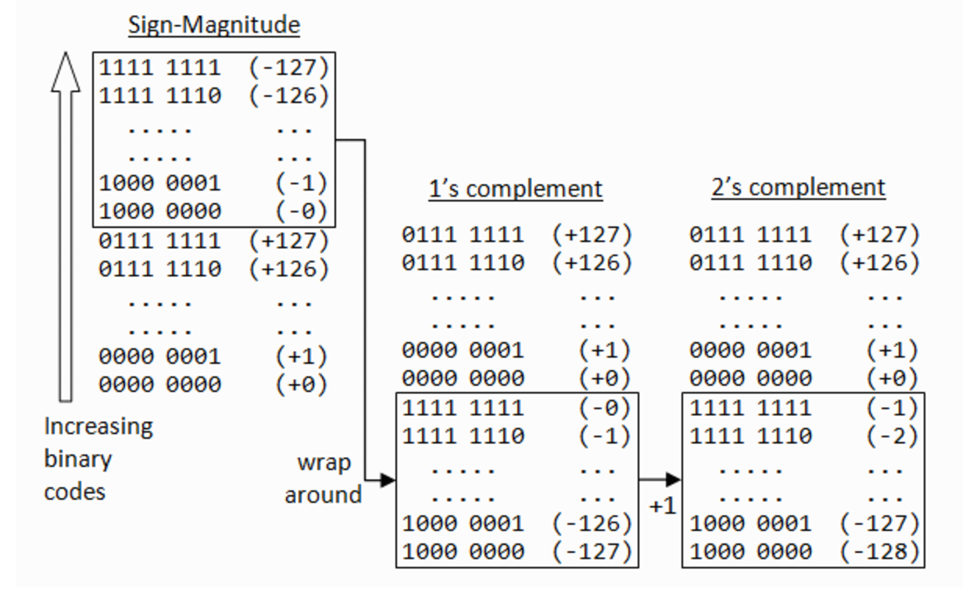

1. **How are decimal numbers (Google “Floating Point”) represented in computer memory? (Include a diagram)**
   * + In memory, a floating point number is represented similarly: One bit has the sign, some bits form the factor as a fixed-precision number (“mantissa”), the remaining bits form the exponent.
2. **A Pixel is computer memory structure used to store image information. How is a Pixel represented in memory? (Include a diagram).**
   * + Each pixel is represented by a binary value. We call this representation of colours a “bit-plane”. Each bit doubles the number of available colours i.e. 1-bit would give us 2 colours, 2-bits would give us 4 colours and 3-bits would give us 8 colours etc.